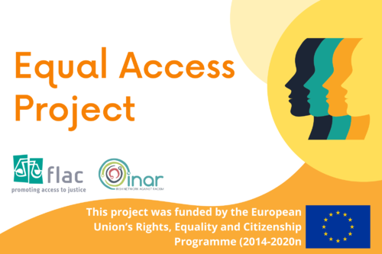

Equal Access Project
Anti-Racism Advocacy Training Programme Evaluation
Terms of Reference

1. Background
The Equal Access Project (EAP) is an EU-funded joint initiative of Free Legal Advice Centres (FLAC) and the Irish Network Against Racism (INAR). The objective of the project is to improve access to justice for people who are subjected to racial discrimination. This will be achieved through providing training to non-legal advocates and conducting a piece of relevant research.
The focus of this evaluation is the EAP Anti-Racism Advocacy training programme. This training was designed and delivered as a QQI-accredited component award in Information, Advice, and Advocacy Practice at Level 6. Its objective was to provide trainees with the knowledge and skills to represent a claimant in a case taken on the Race Ground to the WRC.
The syllabus included: awareness of structural and interpersonal racism; knowledge of the legislative context, the workings of the WRC and the process of making a claim; and the advocacy skills associated with accompanying a claimant through the process and making a clear and thorough case on behalf of the claimant.
The training was delivered online between March 10th and April 21st 2022. Twelve sessions delivered twice a week over 6 weeks were facilitated by the Training Coordinator, and trainers included both in-house and external equality experts and legal practitioners. There were 22 trainees who started the programme. Of this number, thirteen trainees submitted assessments for certification.
The trainees come from across Ireland and there is a diverse range of personal and professional backgrounds represented in the group. Most of them work in some capacity with organisations that deal with issues related to racial discrimination and discrimination on the basis of membership of the Traveller community.
The Anti-Racism Advocacy training programme is a major component of the Equal Access Project. An independent evaluation will assess its impact and sustainability based on a variety of indicators.

2. Evaluation Objectives
Following this initial delivery of the training, the Project Team intends to roll out the programme in partnership with a training provider who can ensure that delivery of the programme will continue beyond the life-cycle of the project. The findings of the evaluation will inform improvements to the programme before it is delivered again.
The evaluation will assess the relevance, effectiveness, and impact of the training programme in relation to the training design, the training materials, and the mode of delivery. Recommendations for future delivery will be made on the basis of this assessment and included in the evaluation report.
The evaluation will answer the following questions:
- What was the impact on the trainees in relation to their professional capacity and their learning experience during the programme?
- Did the training programme achieve its objective?
- Is the training programme replicable? (This should address practical issues such as availability of suitable trainers, accreditation, etc.)
- Were there any unexpected beneficial outcomes?

3. Scope
It is proposed that the evaluation be completed in four weeks. The schedule will be agreed by the Project Team and the Evaluator.
One deliverable will be produced by the Evaluator, which is the Evaluation Report.
The following milestones will be included in the schedule:
- Initial consultation with the Project Team.
- Follow-up meeting with Project Coordinator.
- Delivery of Evaluation Report.
The budget for the evaluation is €4,000.

4. Methodology
The evaluation will be based on consultations with trainees and trainers, and review of the training session recordings and materials. The Project Coordinator will facilitate contact between the Evaluator and trainees and trainers for consultation.

5. Accountability
The Evaluator is accountable to the EAP Project Team. Communications with the Project Team will be conducted via the Project Coordinator. The evaluation report will be submitted to the Project Team.

6. Application Process
Bidders are invited to submit a CV with their relevant qualifications and experience, as well as a short proposal outlining the approach to and methodology for this project based on these terms of reference. Applications should include confirmation of tax compliance and declaration of conflicts of interest. Tenders to be sent to ruth.kilcullen@flac.ie

This project is funded by the European Union’s Rights, Equality and Citizenship Programme (2014-2020).

